**What are Modules, Packages, and Libraries?**

Module – related code saved in 1 file.

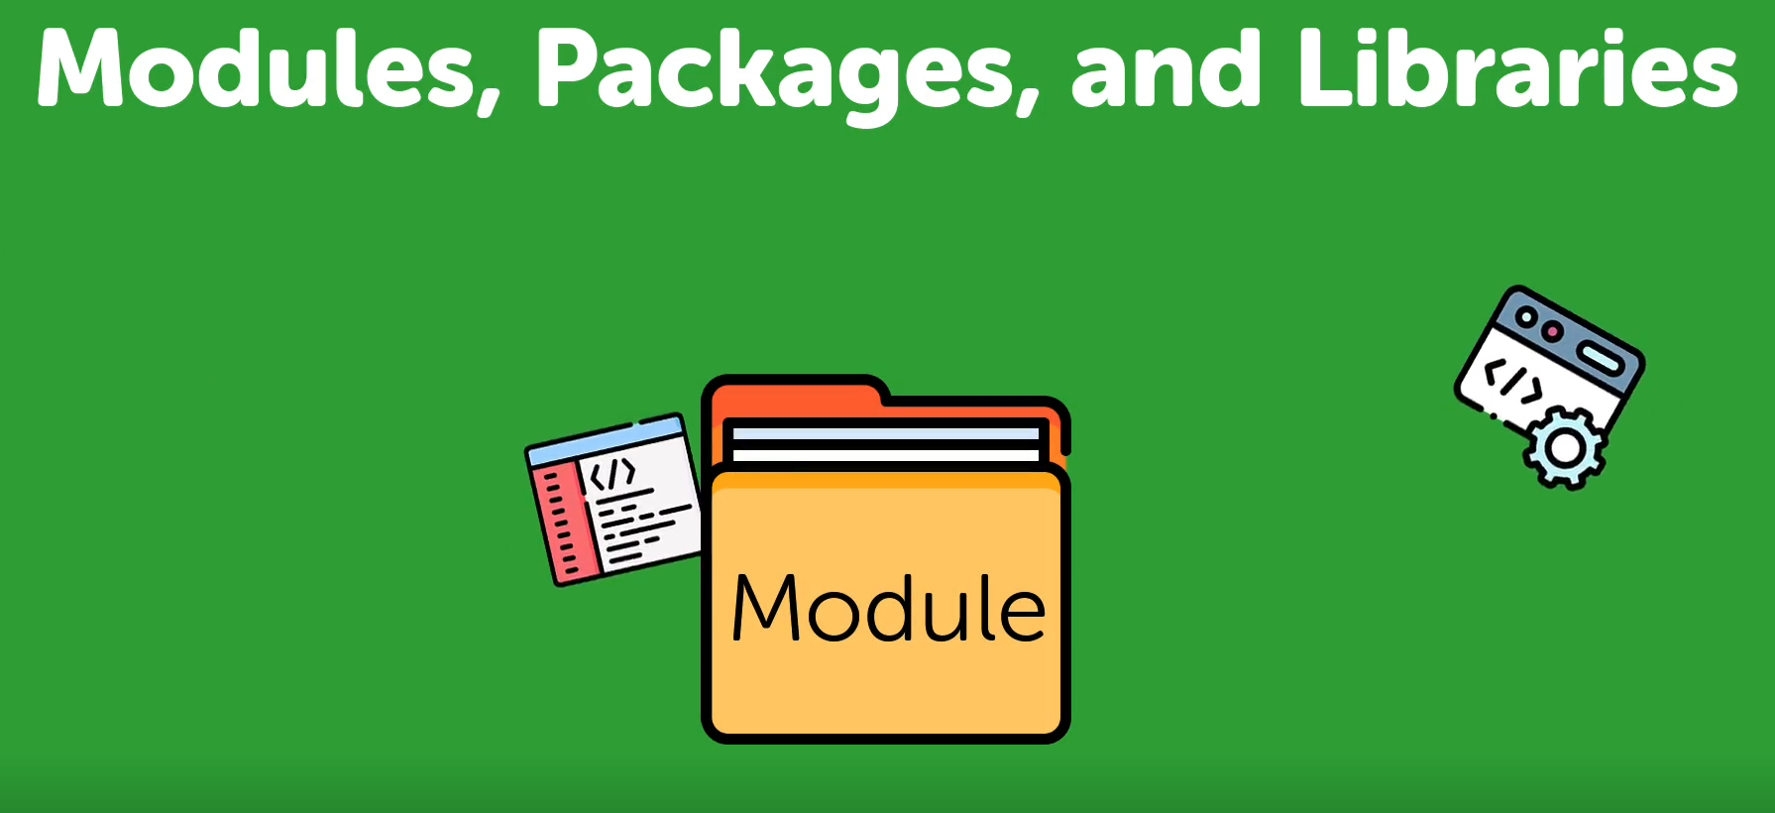

Package is a collection of modules.

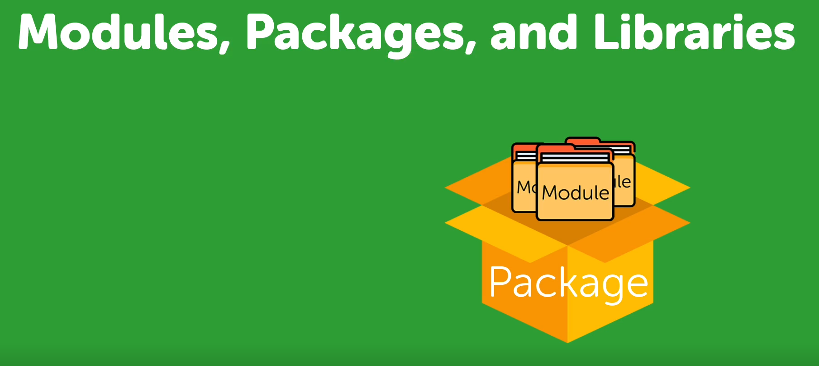

Python library usually contains group of related modules and packages.

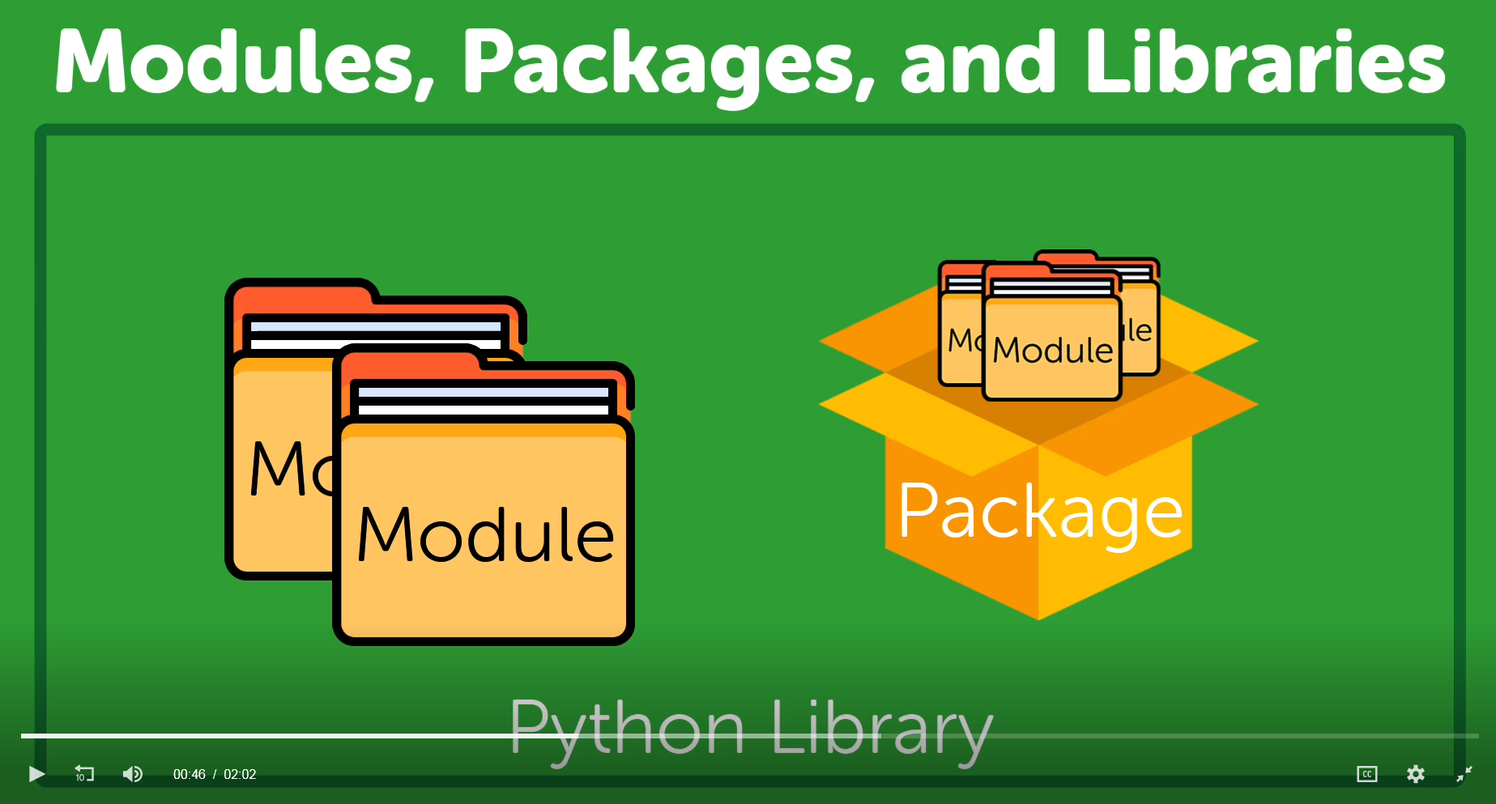

Words library and package are often used interchangeably.

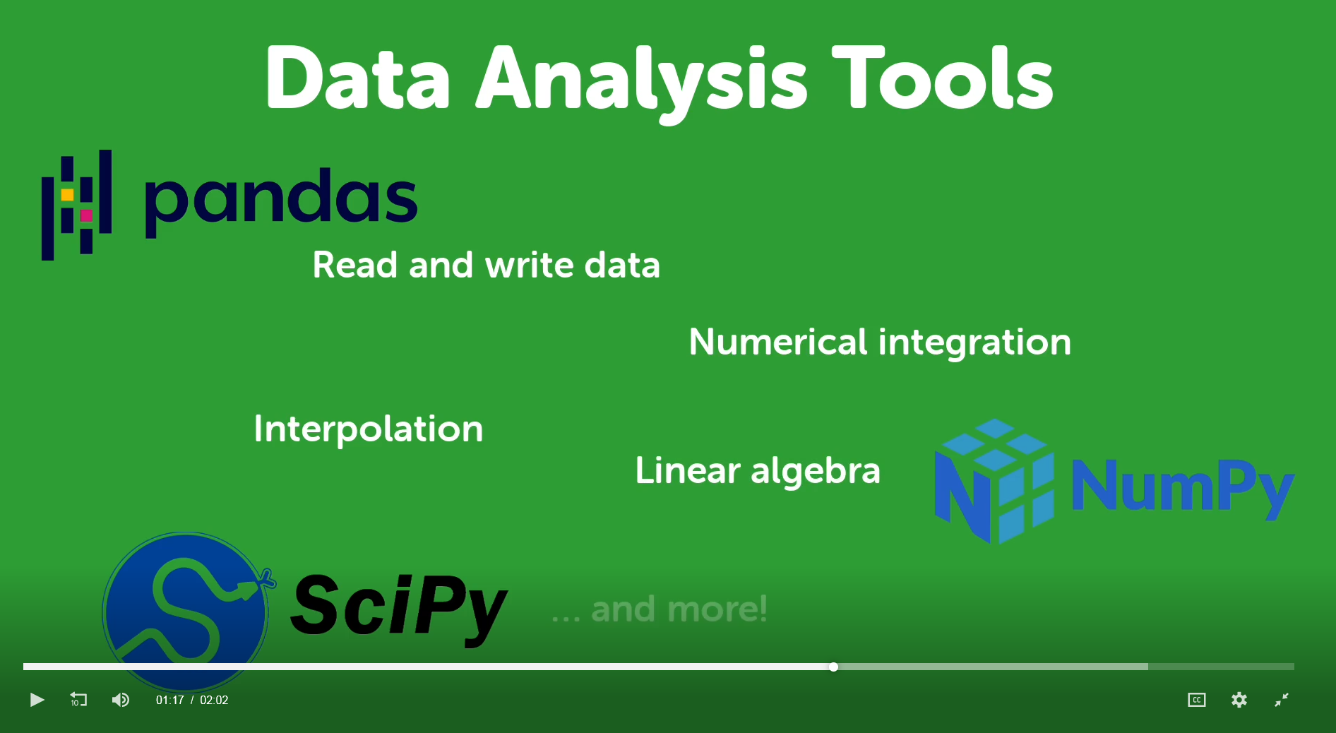

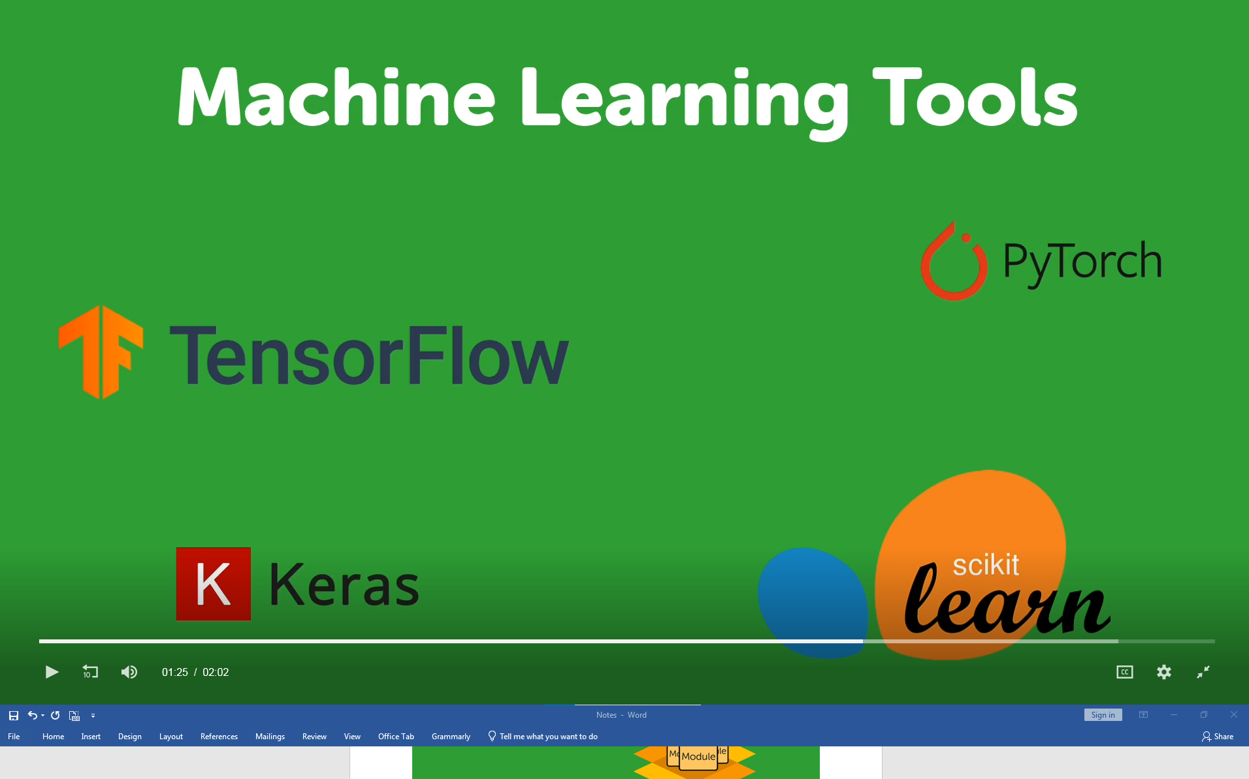

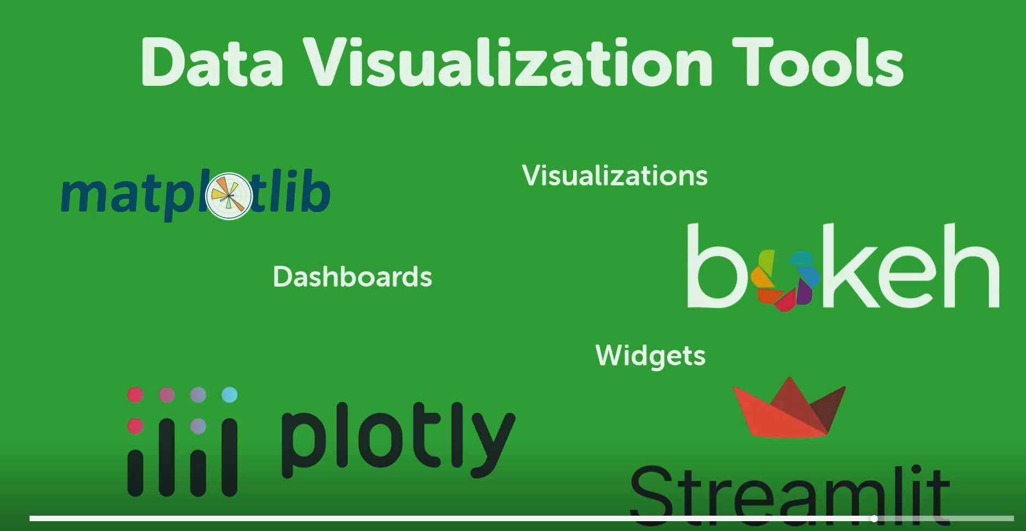

**Understanding Conda**

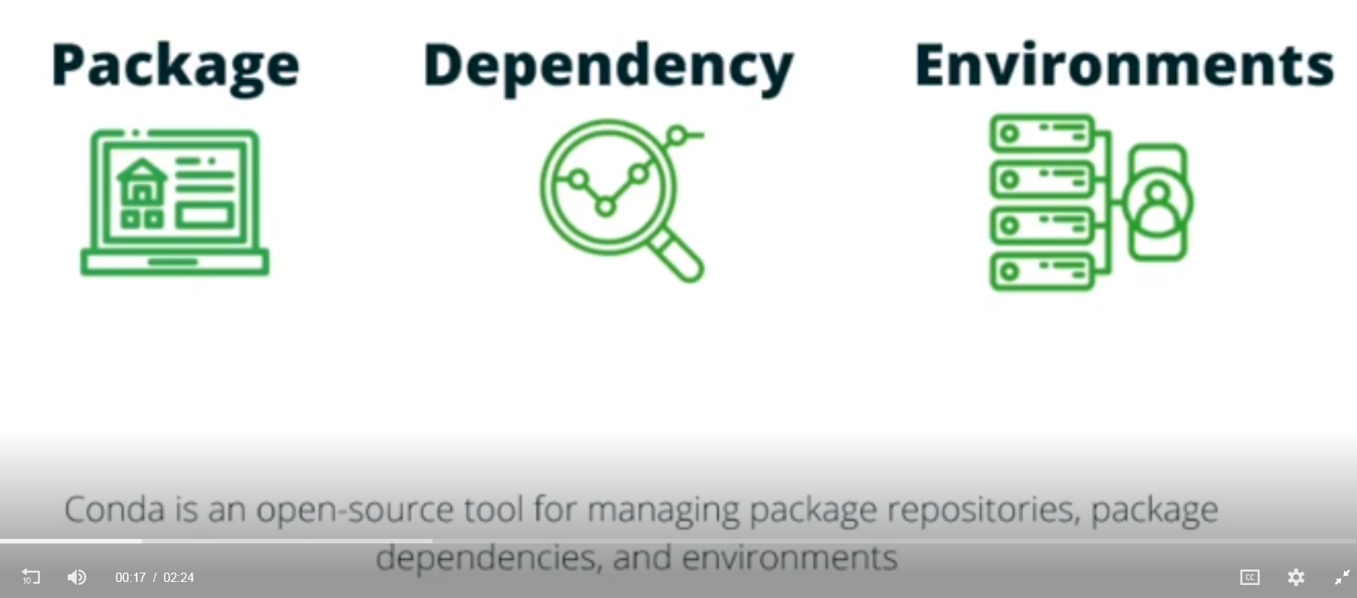

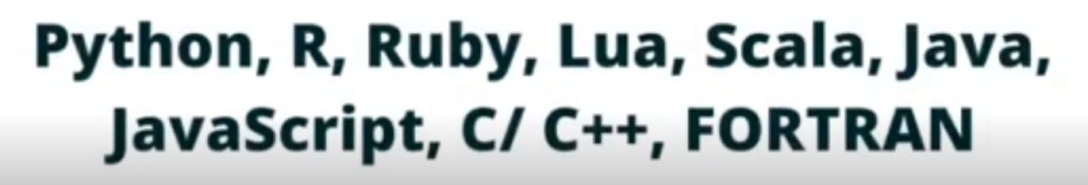

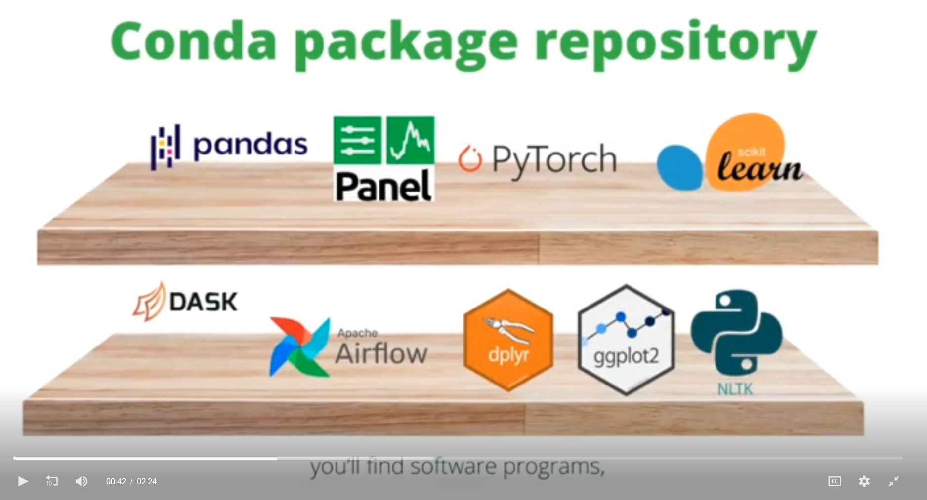

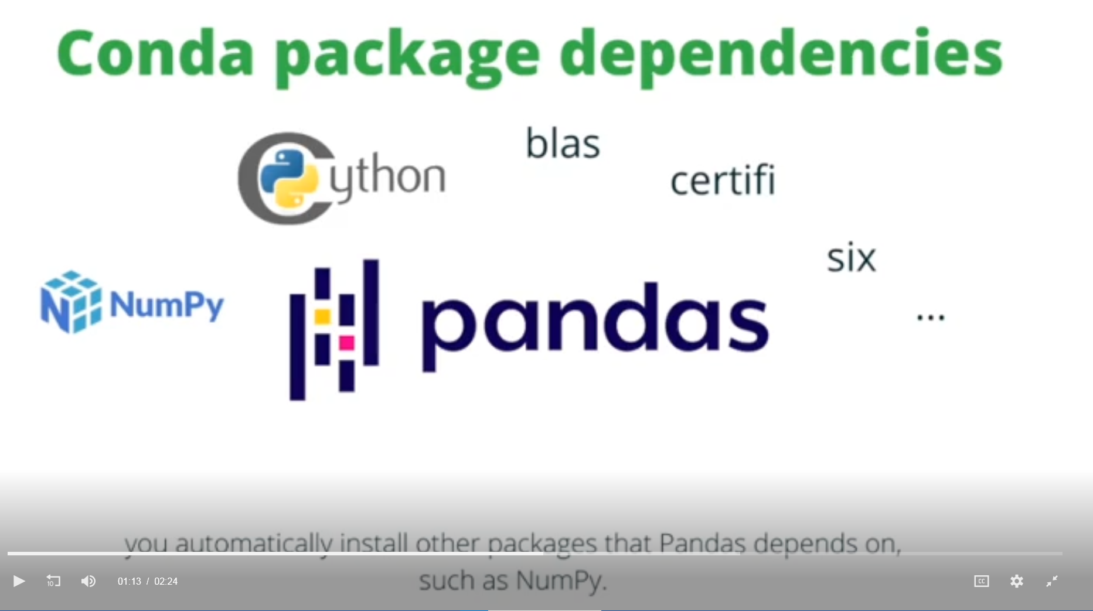

Different environments for different projects. In this case the first one is ML/AI, second ETL and dashboarding, and last is R.

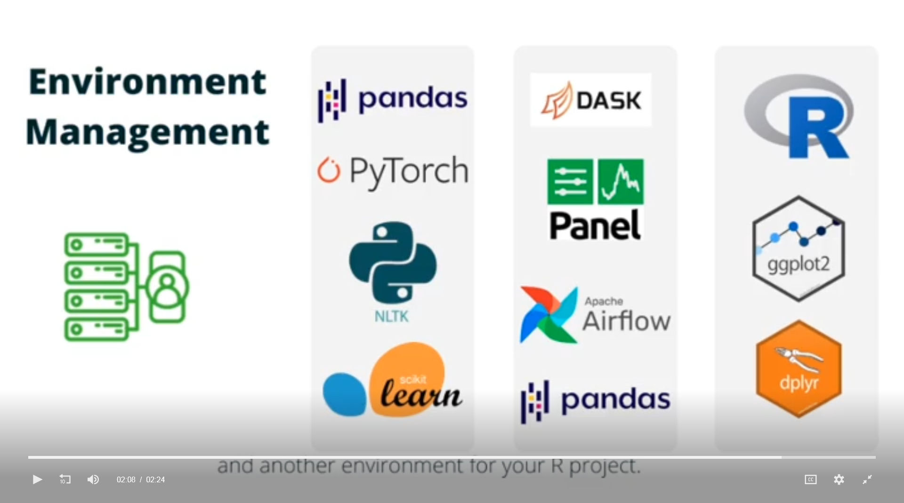

**Conda Workflow: Creating Environments, Installing Packages, and Launching an IDE**

<https://freelearning.anaconda.cloud/get-started-with-anaconda/18202>

**What is an IDE?**

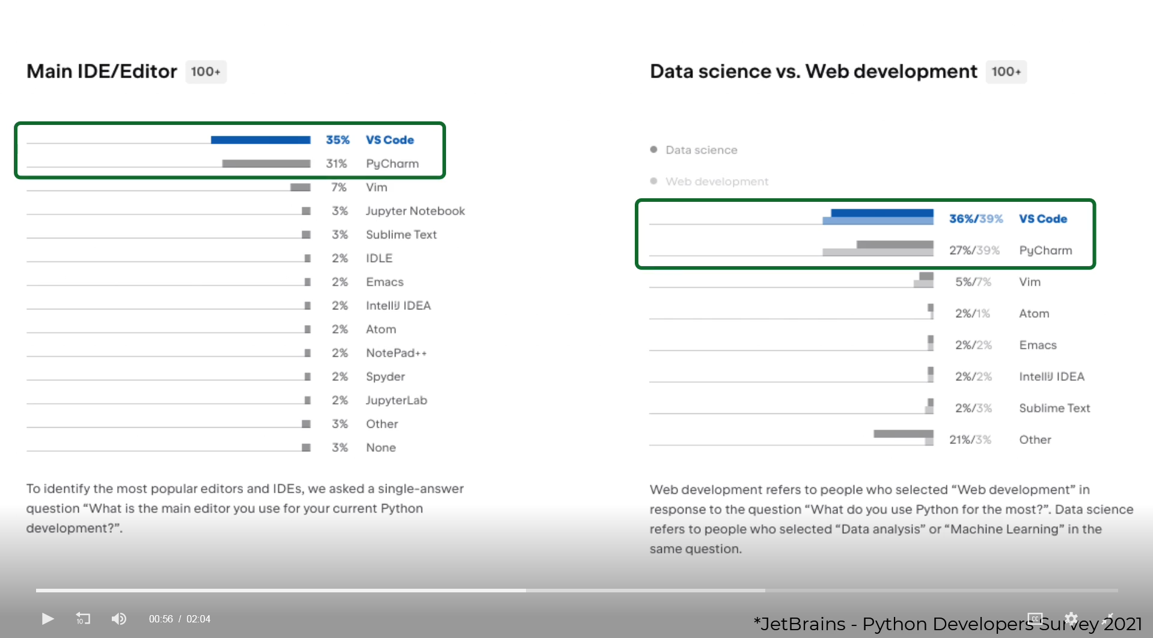

**What is Jupyter Notebook and JupyterLab?**

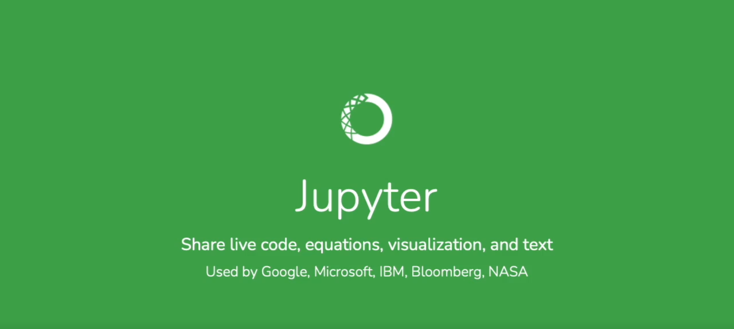

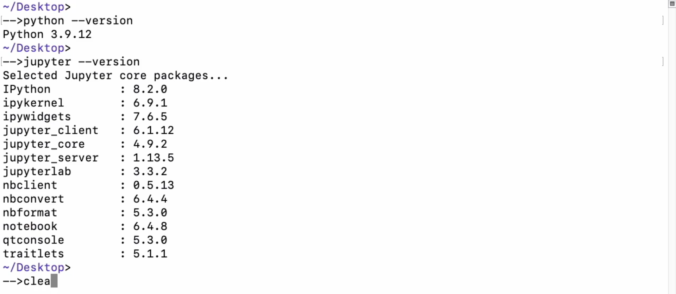

clea = clear

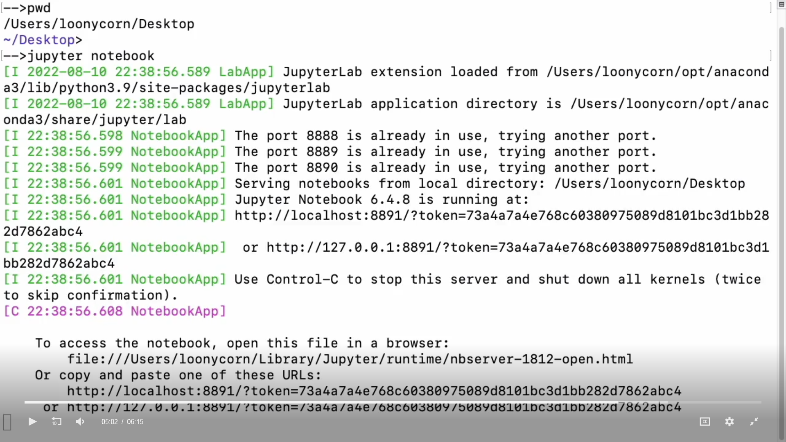

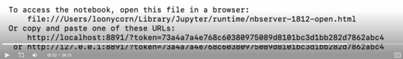

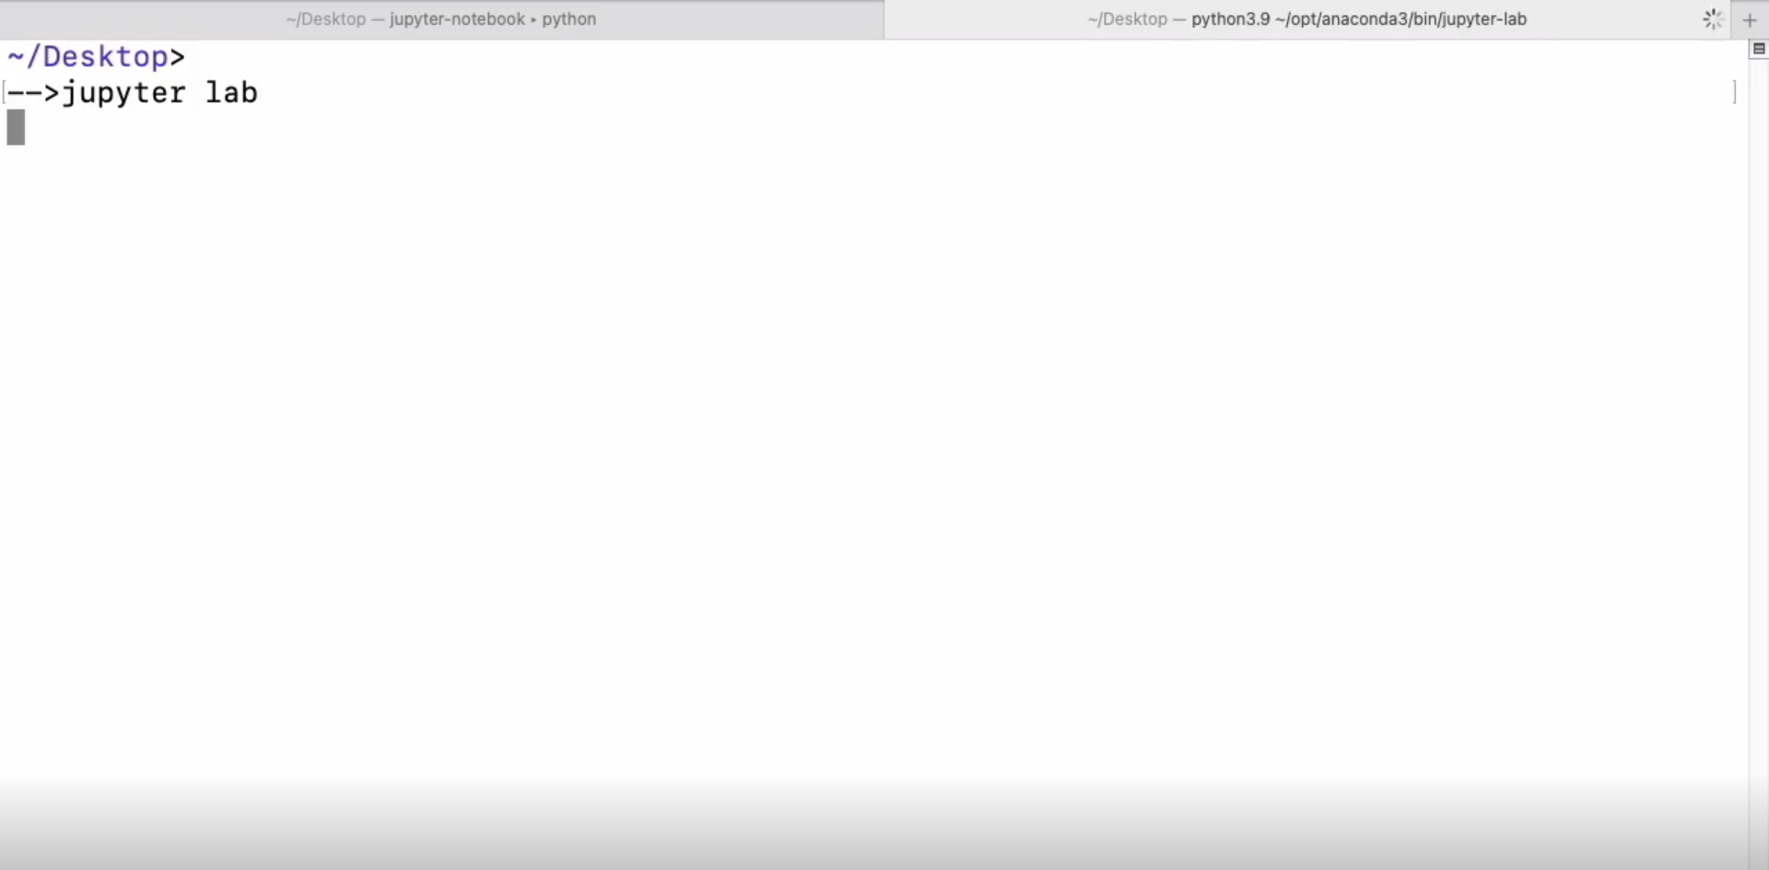

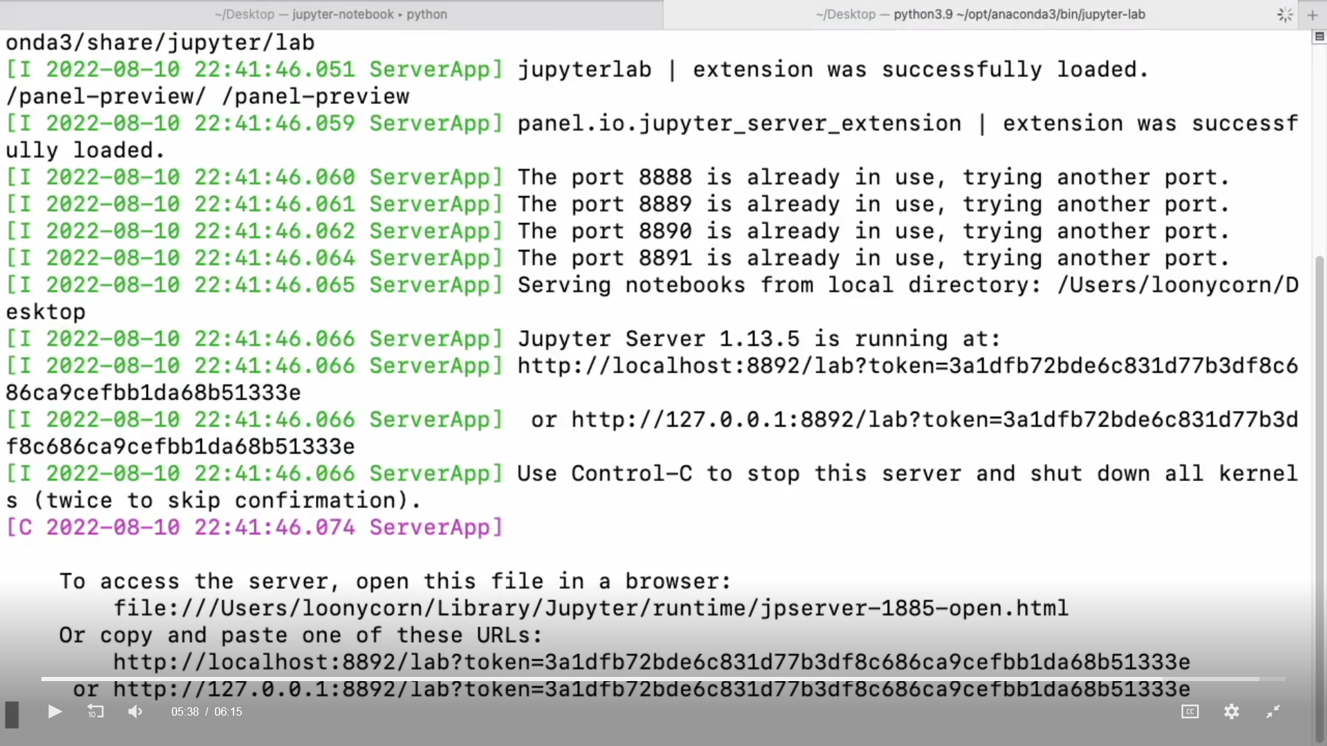

**Getting Started with a Jupyter Notebook and JupyterLab**

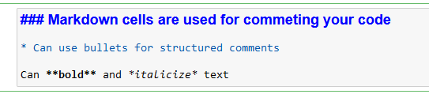

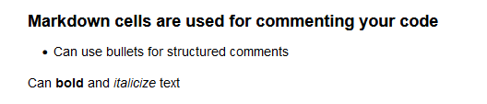

**Create a simple Python program in Spyder**

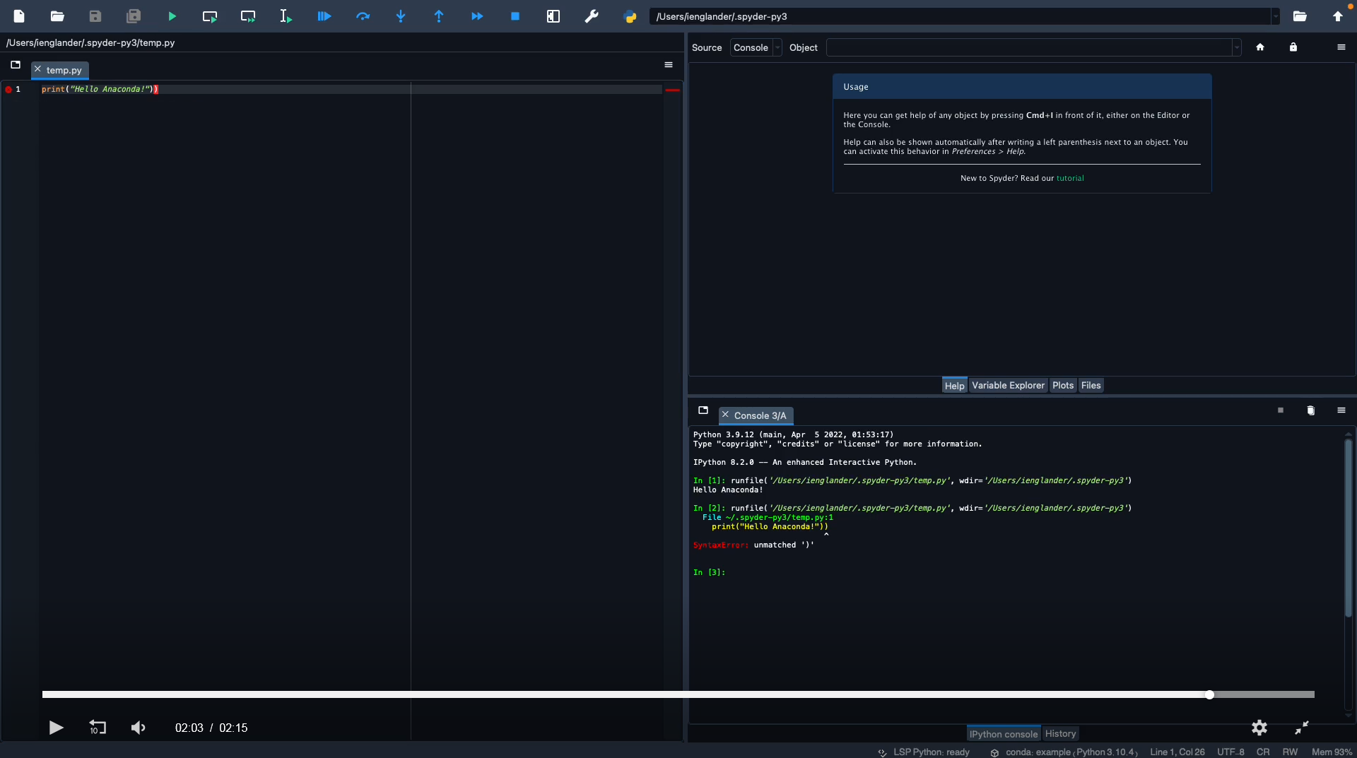

Code in terminal:

* conda create --name [environment name]
* conda activate [environment name]
* conda install ipykernel